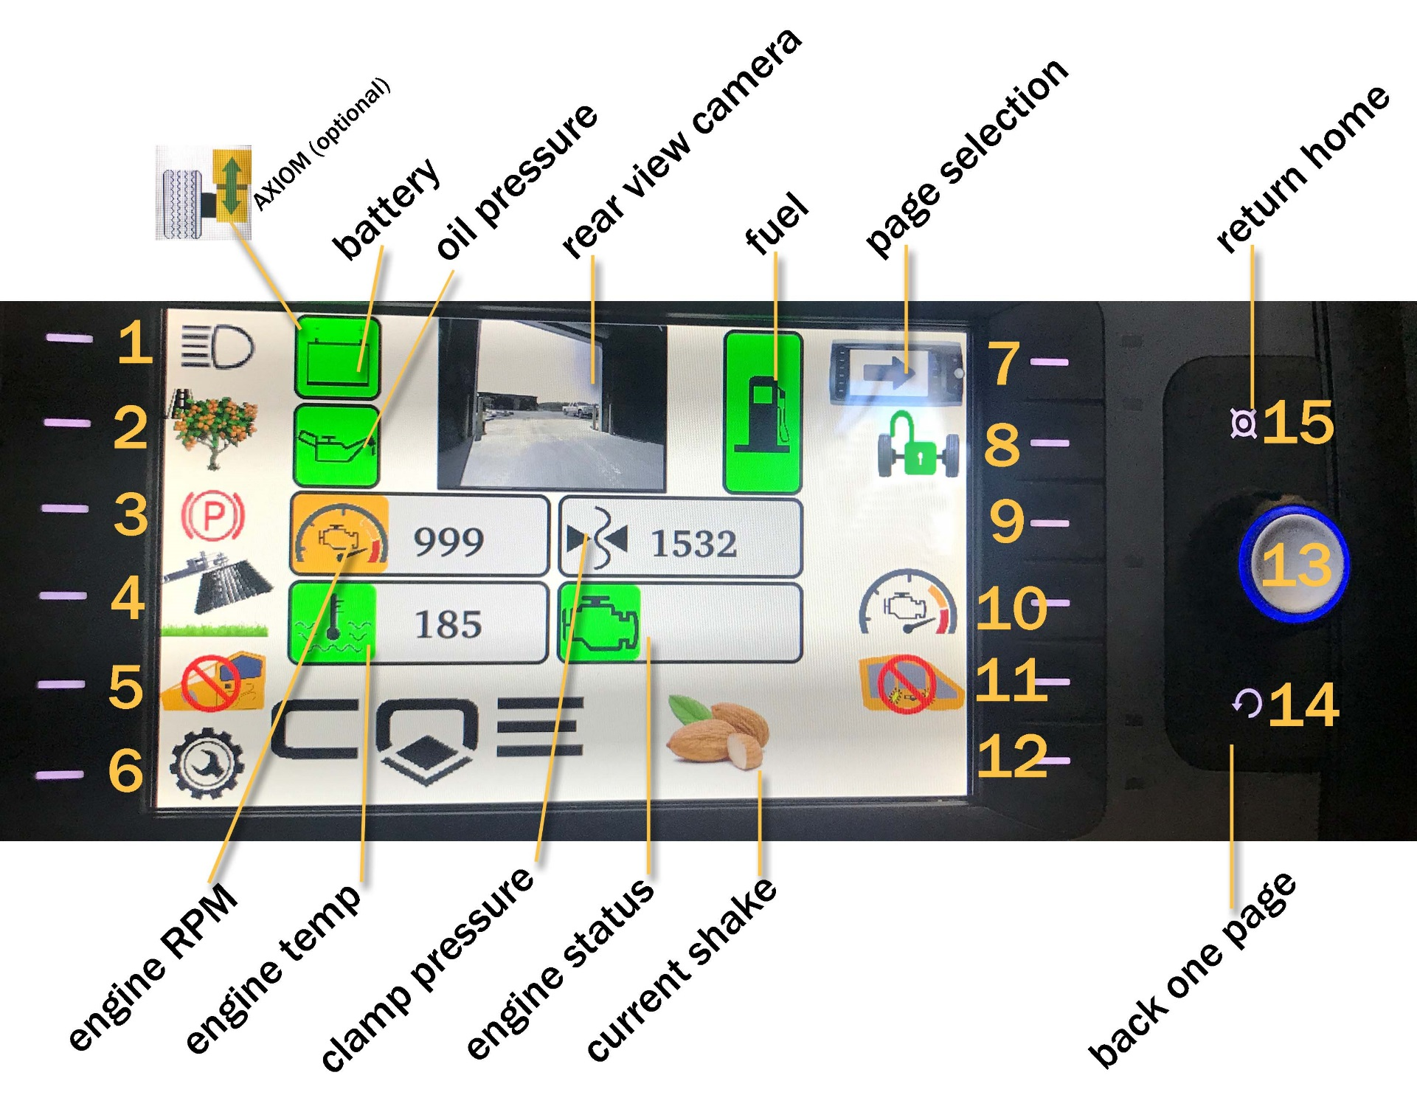

InControl for S7-r   
user guide

ver. July 17, 2018

### 

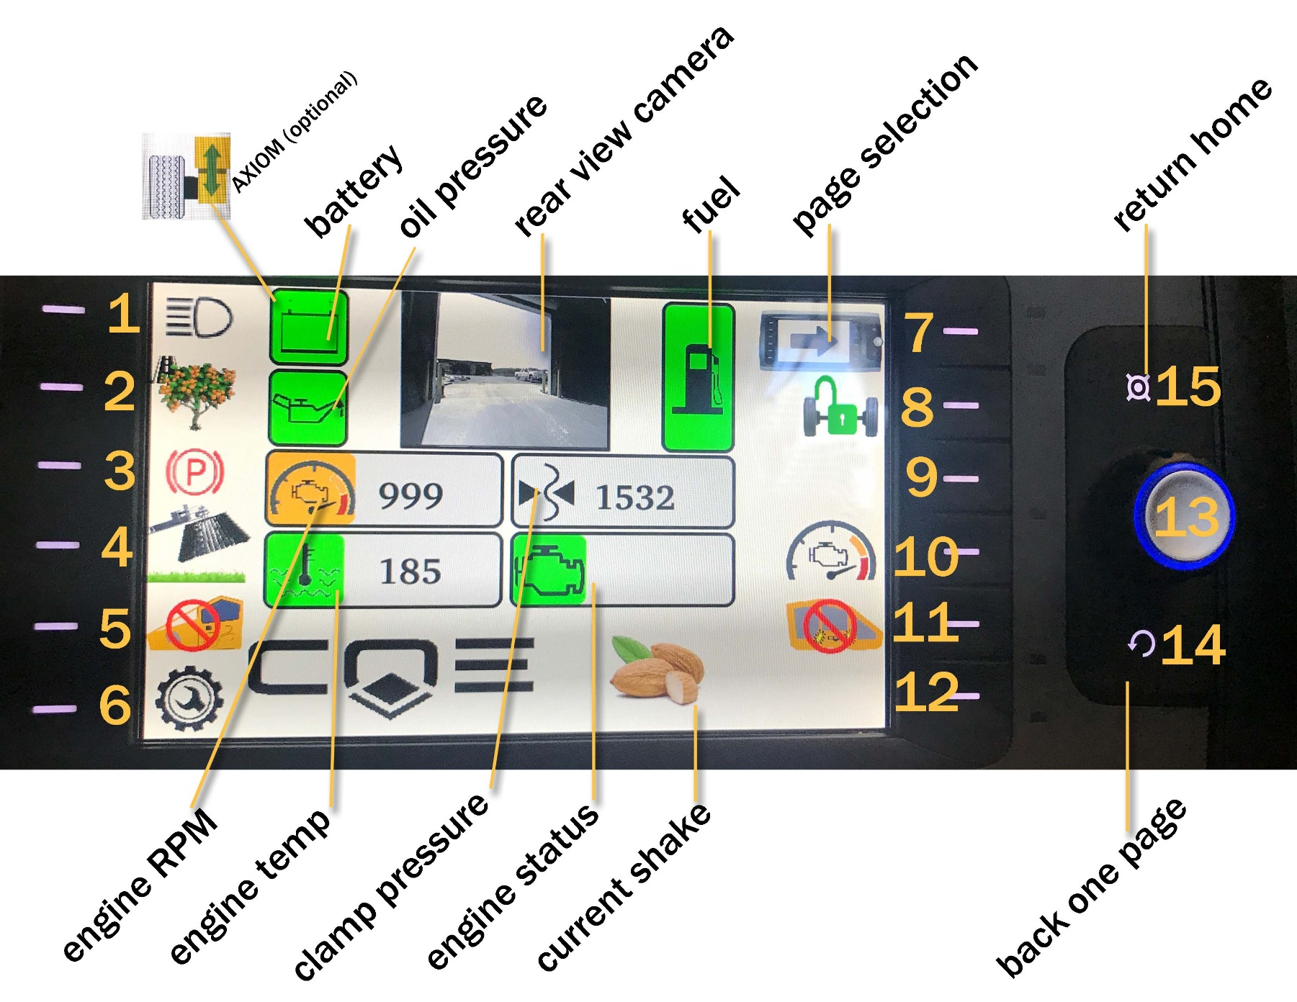

|  |  |
| --- | --- |
| **HOME SCREEN** | |
| 1. Lights on/off | *Blue indicates ON* |
| 1. Harvest/Travel | *Tree indicates Harvest Mode, Road indicates Travel Mode; Travel mode uses auto flashers; use dial to achieve 2400 RPM* |
| 1. Parking brake | *Red indicates ON; press & hold for 5 seconds for Auto Brake (green)* |
| 1. Sweeps up/down | *Up position indicates OFF* |
| 1. Cab pressurizer |  |
| 1. Engine & Bodas service |  |
| 1. Page Two/Return Home |  |
| 1. Traction |  |
|  |  |
| 1. Engine RPM control |  |
| 1. Flashers on/off | *while in Harvest mode; always ON in Travel mode* |
|  |  |
| 1. Wheel | *Clockwise/counter-clockwise, push in to select* |
| 1. Previous Screen |  |
| 1. Return to Home | *From any screen* |

**NAVIGATION OPTIONS**

* Touch Screen
* Soft Keys
* 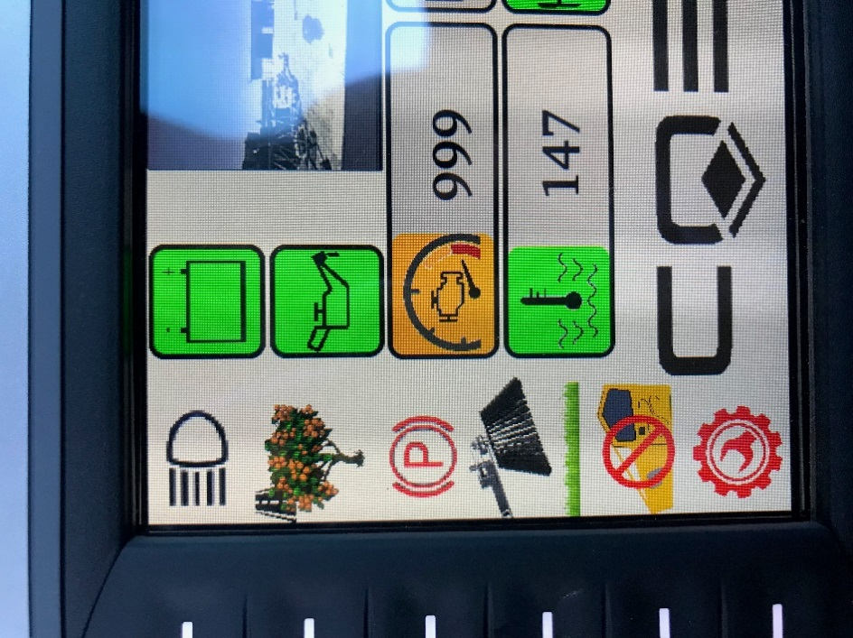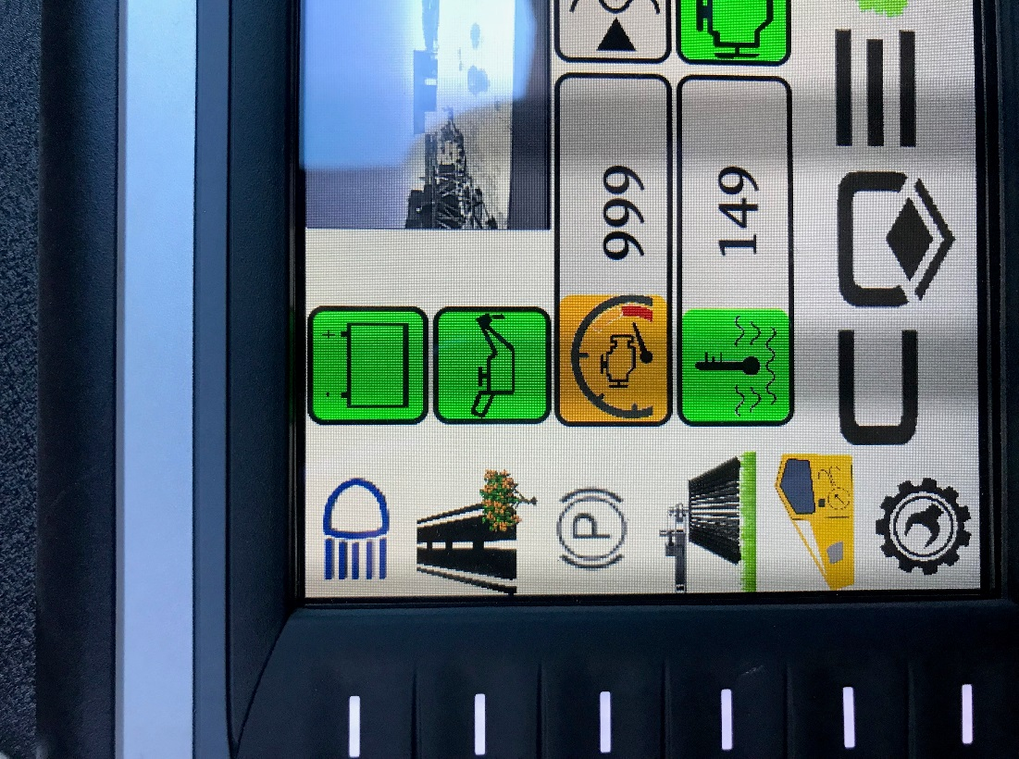Wheel (13)
* Image result for black undo symbol (14) Previous Screen & (15) Home

**FOR YOUR SAFETY**

* While in **E-Shake** or **Custom** mode, unclamp or **Joystick** trigger will stop & cycle
* Only make adjustments while machine is in **Park**

|  |  |
| --- | --- |
| **ADJUSTING RPM** | |
|  | Press 10 to access engine RPM |
|  | Use Wheel (13) to raise/lower RPM; clockwise increases, counter-clockwise decreases |
|  | * Press **Rabbit** for Harvest RPM, press **Turtle** to return to idle * **Rabbit** default is 2200 RPM * **Turtle** default is Idle |
|  | Below 2000 RPM, shake will not engage, indicated by yellow RPM icon  Above 2000 RPM, shake will engage, indicated by green RPM icon |
|  | In travel/road, use dial to achieve 2400 RPM |

|  |  |
| --- | --- |
| **AXIOM FEATURE** | |
|  | **AXIOM** is an optional feature that will be indicated on the **Home** screen |
|  | * Use to Raise * Use to Lower * Once desired height is reached press above icon to return to **Home** screen & enable throttle * While **AXIOM** is elevated, **Travel** mode is disabled. |
| **SERVICE DIAGNOSTICS** | |
|  | Flashes red when service is required; pressing will display engine & equipment fault codes |
|  | Indicates no water in the tank OR malfunction in monitoring pressure switch |
|  | Press 14 & 15 simultaneously to access Quick Diagnostics Page |
|  | Press & HOLD **Pad Water** icon to prime water pump |

|  |  |
| --- | --- |
| **SETTING PASSWORD** | |
|  | Most functions on Page 2 are password protected. If the icon is red, no changes can be made. To input password, press **Password** icon on any screen |
|  | A blue Password screen will pop up |
|  | * Using Wheel (13), select number by scrolling then push in to enter the number |
|  | * Or touch 0-0-0-0 & key pad will display; input desired code & press OK |
|  | If desired code is entered password icon becomes green |
|  | **Factory password is 1944** |
|  | **TO CHANGE PASSWORD**   * 1944 will always work as default * Follow above steps to enter correct password * Once icon is green press **Password** again; at blue Password pop-up press **Reset** * Use above steps to enter new desired password * Now new and Factory password will access system |

|  |  |
| --- | --- |
| **PAGE TWO** | |
|  | From the **Home** screen, touch the **Arrow** to move forward to **Page Two** |
|  | Once in **Page Two**, touch desired Page icon or rotate wheel & depress when desired Page is highlighted yellow |
|  | |
| **HOME** | |
|  | Press to return to Home OR press Image result for home icon(14) or (15) |
|  | |

|  |  |
| --- | --- |
| **SHAKE CONTROL** | |
|  | |
|  | * **Shake Control** Screen varies by Option selected * **Shake Control** can be accessed while in **E-Shake** through the **Joystick** trigger. This is useful when shaking a smaller replant. |
|  | *Option:* **Manual HD – MD – LD** |
|  | * Shows displacement range for HD/MD/LD * Adjustable in range- push **Adjust** * Once highlighted move w/ finger or corresponding button * Mode allows operator to use displacement pedal to vary shake within range |
|  | When in Manual Mode, **Home** screen will display like this |
|  | *Option:* **E-Shake** |
|  | * **Amplitude** = amount of shake * **Period** = length of shake * **Number of Cycles** = number of times repeats cycle * **Peak Hold** = amount of time at peak amplitude   After adjustment to above options, press & HOLD clamp/shake button to visually graph sequence |
|  | When in E-Shake mode, **Home** screen display like this; when in E-Shake mode, auto-clamp feature is active |
|  | *Option****:* Custom** **Shake 1-4** |
|  | * Use wheel to move & select position or time; depress & rotate wheel to adjust. * Position is amount shake * As shake sequence is produced, graph will visually indicate pattern. |
|  | When in Custom Mode, **Home** screen will display like this; when in Custom Mode, auto-clamp feature is active  Correlates to custom cycle chosen |
|  | |
| **REAR CAMERA** | |
|  | |
|  | * Allows for larger viewing * Traveling in reverse also displays full screen camera |

|  |  |
| --- | --- |
|  | |
| **TREE COUNT (JOB COUNT)** | |
|  | |
|  | * Job count can be reset by pushing **Job Count Reset** button * Clamp/shake & forward travel is needed to count as a job |
|  | |

|  |  |
| --- | --- |
| **SHAKE THRESHOLD (CLAMP PRESSURE ADJUSTMENT)** | |
|  | |
| cid:b659a76b-9f92-43e9-993c-a969be276ef1@namprd19.prod.outlook.com | * Press **Set Up** |
|  | * Desired clamp pressure changes to teal |
|  | * Press & HOLD **Clamp** button & rotate (13) wheel. Clockwise increases clamp pressure, counter-clockwise decreases clamp pressure. Once desired pressure is met release **Clamp** button on joystick. |
|  | Current clamp pressure will be displayed on **Home** screen |
|  | * Also in this screen you can turn water off/on for testing & cleanliness reasons if in a shop & testing the head * Press this icon to turn the pad water on/off * Press this icon to turn the sling water on/off |
| cid:afbd21a1-77b4-480a-82d5-38f1729937ac@namprd19.prod.outlook.com | * **Free Wheel Mode** * Free Wheel Mode is the preferred mode. * It allows the machine to position itself correctly when shaker-head-to-tree alignment is improper. * Free Wheel Mode should not be used in hilly terrain. * Free Wheel Mode enabled. |
| cid:b659a76b-9f92-43e9-993c-a969be276ef1@namprd19.prod.outlook.com | * Press this icon to disabled Free Wheel Mode. |

|  |  |
| --- | --- |
| **OPERATOR ADJUSTMENT** | |
|  | |
|  | * **Sweeper On Time** = time brush will rotate after stop * **Sweeper** = adjust speed of sweeper rotation * **Acceleration** = Increase/decrease speed of shaker acceleration * **Deceleration** = increase/decrease speed of shaker deceleration   *Highlighted icon turns yellow, then drag finger OR use wheel (13) to increase/decrease* |
|  | * On longer spacing shaker will begin to shift for quicker tree-to-tree times. If spacing is below 18’, 1st Gear Only may be used to avoid shifting. |
|  | * 2nd Gear Only will put shaker’s front wheel in minimum displacement which will keep front tire from spinning in loose soil conditions or when loading equipment on trailers. |
|  | * **Pad Lube** = increase/decrease water to filled pads * **Sling Lube** = increase/decrease sling lube; typical range is .5-1.0 sec of water per injection cycle. * **Tree Release %** = amount head will open in auto shake mode * **Clamp Open** = increase/decrease speed of clamp open * **Clamp Close** = increase/decrease speed of clamp close   *Highlighted icon turns yellow, then drag finger OR use wheel (13) to increase/decrease* |
|  | * **Head Retract** = increase/decrease speed of head retract * **Head Extend** = increase/decrease speed of head extend * **Head Raise** = increase/decrease speed of head raise * **Head Lower** = increase/decrease speed of head lower   *Highlighted icon turns yellow, then drag finger OR use wheel (13) to increase/decrease* |
|  |  |

|  |  |
| --- | --- |
| **BODAS SERVICE** | |
|  |  |
|  | Allows access for factory/dealer service on equipment system |